**Oyster Task Force Meeting**

**Tuesday, January 8, 2025, 10:00am**

**New Orleans Lakefront Airport**

**6001 Stars and Stripes Blvd.**

**New Orleans, LA**

I. Pledge of Allegiance

II. Roll call and introduction of guests

**Voting Members Present:**

Jakov Jurisic

Mitch Jurisich

Brad Robin

Brandt Lafrance

Al Sunseri

Sam Slavich

Willie Daisy

Steve Pollock

**Voting Members Absent:**

Shane Bagala

Dan Coulon

Brandon Debarge

Matthew Slavich

Peter Vujnovich

**Non-Voting Members Present:**

Robert Caballero

Davis Madere

Kyle Balkum

**Non-Voting Members Absent:**

Justin Crossie

Brian Lezina

Jakov Jurisic acknowledged a moment of silence for the French Quarters attack victims and their families

**III.** Jakov Jurisic motioned to approve the November 19, 2024 meeting minutes, 2nd by Brad Robin. Motion carries.

Jakov Jurisic motioned to approve the January 8, 2025 meeting agenda as presented, 2nd by Brad Robin. Motion carries.

IV. Treasury Report

Remaining Fund Balance- $548,237

Remaining Budget Balance- $67,726

December Oyster Tag Sales- 142,800

Brad Robin motioned to approve the treasury report as presented, 2nd by Jakov Jurisic. Motion carries.

**V.** Committee Reports

A. Public-Private Oyster Seed Grounds Committee- no report

B. Enforcement Report- November 11th  – December 15th

**Region 4** (Iberia)

**Region 5** (Calcasieu and Cameron)

Cameron

**Seizures:**

**Region 6**: (Terrebonne, Lafourche, Grand Isle)

Terrebonne

1- 40:4A violate sanitation code (Refrigeration)

**Seizures:**

**3 sacks**

**Region 8**: (Jefferson, Plaquemines, St. Bernard, Orleans

**St. Bernard**

2 - RS 56: 433 A – Take Undersized Oysters from Natural Reef.

8 – RS 56:306.5 – Failure to Maintain Records.

1 Warning – RS 56: 433 A – Take Undersized Oysters from Natural Reef. (First Offense)

**Seizures:**

10- Sacks seized in connection with these violations and returned to water.

Plaquemines

**Seizures:**

C. Legislative Committee- Brad Robin was appointed the new Legislative Committee chairman while Jakov Jurisic is out. The task force will possibly propose some legislative this session to add a new seat on the task force for a Department of Ag and Forestry representative

D. Legal Committee- no report

E. Research Committee- Earl Melancon provided the committee report, the Research Committee met prior to the full OTF meeting and discussed the 2025 State of the Coast Conference which will be held on May 20-22, 2025 at the New Orleans Convention Center. Brad Robin and Jakov Jurisic volunteered to participate in the panel discussion at the conference. The panel will address both traditional and AOC environment and socioeconomic challenges within their respective type of industry. Presenters are required to register but registration and will be covered for panelists. The committee also discussed the 2025 LA Regional Fisheries Forward Mini-Summit.

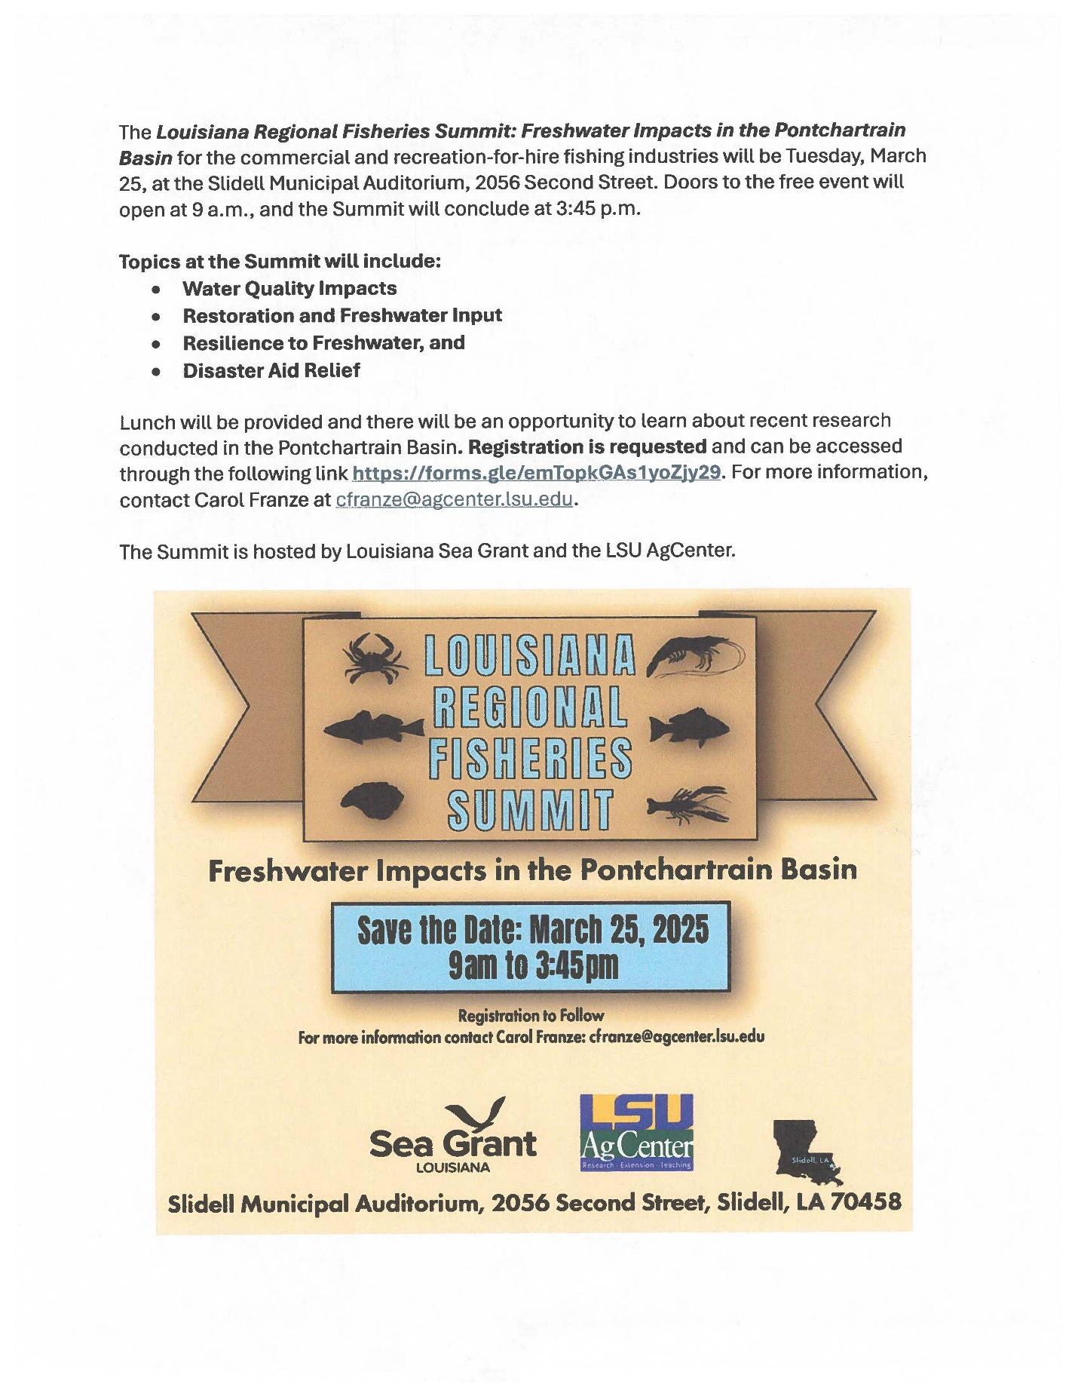

The Committee also discussed and unanimously agreed to write a letters of support for both of the following proposals submitted by Dr. Elizabeth Robinson: 1. Louisiana Sea Grant Aquaculture Internship Pilot Program

2. Development of a Community of Practice Program for Louisiana’s Off-Bottom Aquaculture Industry

Brad Robin motioned to write letters of support for both of Dr. Elizabeth Robinson’s proposals, 1. Louisiana Sea Grant Aquaculture Internship Pilot Program, 2. Development of a Community of Practice Program for Louisiana’s Off-Bottom Aquaculture Industry, 2nd by Jakov Jurisic. Motion carries.

The committee lastly discussed research needs identified by LA Sea Grant for 2026-2028 funding opportunities and the importance to the oyster industry

Dr. John Zach Lea suggested a LDWF/ CPRA Salinity Management Plan as a possible topic of research

F. Coastal Restoration Committee- Captain George Ricks provided an update

**CAERNARVON INTERAGENCY ADVISORY COMMITTEE ANNUAL MEETING FOR 2025 OPERATIONS**  
**Wednesday   |   December 11   |   9:00 – 10:30 AM**  
Flood Protection Authority-East  
Board Room 201  
6920 Franklin Avenue  
New Orleans, LA 70122

G. Marketing Committee- Anna Koehl presented the task force with an annual media plan

Jakov Jurisic motioned to amend the agenda by adding item C-2 under New Business, To Consider Funding for the January Oyster Task Force Annual Plan Media Buys, 2nd by Brad Robin. Motion carries with a unanimous vote.

H. Health Committee- Jennifer Armentor provided an update on the health illness report

Jennifer Armentor stated LDH is putting in a proposal to put an indication on gallon oyster containers “not for raw consumption” as there is no vibro control plan

Al Sunseri stated that he disagrees with the proposal as it’s been a standard practice to eat raw oysters out of the gallon containers, believes this is overkill that LDH would propose a regulation change from one instance that may not have even been oyster related, opposed changing labeling for shucked oyster containers

Jen Armentor stated that she will speak to her higher-ups and will relay the OTF comments and concerns; may be looking to do something at ISSC this year

ISSC is set for October 18-23, 2025 in Denver; Steve Polluck stated that he would like to be replaced on the ISSC as he is unable to make the whole meeting

I. Aquaculture Committee-

J. Joint Task Force Working Group Committee- no report

**VI.** New Business

1. Robert Caballero provided an update on the oyster season

2024-2025 Oyster Season

Oyster season comprehensive update as of 01/05/2025; broken down by Louisiana Department of Wildlife and Fisheries (LDWF) Coastal Study Area (CSA) or Louisiana Department of Health (LDH) shellfish harvest area.

**Table 1**. Harvest estimates for the 2024-2025 oyster season on Louisiana’s public oyster areas as of 01/05/2025. Harvest estimates are based on either LDWF conducted surveys of oyster harvesting vessels during the oyster season or from daily harvest reporting requirement via eReporting application.

|  |  |  |  |  |  |  |  |  |
| --- | --- | --- | --- | --- | --- | --- | --- | --- |
| **CSA** | **Area** | **Season Opening** | **Season Closure** | **Season/**  **type** | **Days open to Date** | **eReporting Harvest** | **Boarding Report Harvest** | **Vessels Harvesting** |
|
| **1** | POSG East of Mississippi river and North of MRGO | 23-Sep-24 | 25-Sep-24 | Bedding season | 3 | 3,435 bbl | 10,250 bbl | 20 |
| 1-Nov-24 | 30-Apr-25 | Market harvest | 66 | 40,982 sacks | 51,178 sacks | 83 |
| **3** | Little Lake/ Hackberry Bay | 23-Sep-24 | 25-Sep-24 | Bedding season | 3 | 175 bbl | 152.5 bbl | 4 |
| Hackberry Bay | 1-Nov-24 | 30-Apr-25 | Market harvest | 66 | 261 sacks | 381 sacks | 5 |
| Little Lake | 14-Oct-24 | 30-Apr-25 | Market harvest | 18/84 | 160 sacks | 260 sacks | 4 |
| **5** | Lake Mechant/ | 23-Sep-24 | 25-Sep-24 | Bedding season | 3 | 120 bbl | 660 bbl | 4 |
| Bay Junop | 21-Oct-24 | 25-Oct-24 | Market harvest | 5 | 485 sacks | 1,704 sacks | 21 |
| **6** | Vermilion/East and West Cote Blanche Bay/Atchafalaya Bay | 23-Sep-24 | 30-May-25 | Bedding season | 105 | 0 | 0 | 0 |
| 14-Oct-24 | 30-May-25 | Market harvest | 84 | 0 | 0 | 0 |
| **7** | Calcasieu Lake | 1-Jan-25 | 30-Apr-25 | east side: Market harvest | 5 | 0 | 0 | 0 |
| 15-Oct-24 | 30-Apr-25 | West Cove: Market harvest | 48/83 | 134 sacks | 935 sacks | 4 |

**Table 2**. eReporting harvest summary for the 2024-2025 oyster season on Louisiana’s public oyster areas.

|  |  |  |  |  |
| --- | --- | --- | --- | --- |
| **LDH Area** | **Activity** | **Volume** | **Number of Vessels Harvesting** | **Harvest Trips** |
| Zone 1 | Bedding | 60 bbl | 1 | 2 |
| Zone 2 | Bedding | 3,375 bbl | 9 | 16 |
| Sacking | 1,187 sacks | 18 | 49 |
| Zone 3 | Sacking | 39,711 sacks | 76 | 1,376 |
| Zone 4 | Sacking | 84 sacks | 1 | 5 |
| Zone 13 | Bedding | 175 bbl | 2 | 4 |
| Sacking | 421 sacks | 5 | 16 |
| Zone 21 | Bedding | 120 bbl | 2 | 4 |
| Sacking | 485 sacks | 7 | 18 |
| Zone 30 | Sacking | 134 sacks | 3 | 16 |
| **Grand Total** | **Bedding** | **3,730 bbl** | **14** | **26** |
| **Sacking** | **42,022** | **86** | **1,480** |
| **LDH Area** | **Activity** | **Volume** | **Number of Vessels Harvesting** | **Harvest Trips** |
| Zone 1 | Bedding | 60 bbl | 1 | 2 |
| Zone 2 | Bedding | 3,375 bbl | 9 | 16 |
| Sacking | 1,187 sacks | 18 | 49 |
| Zone 3 | Sacking | 39,711 sacks | 76 | 1,376 |
| Zone 4 | Sacking | 84 sacks | 1 | 5 |
| Zone 13 | Bedding | 175 bbl | 2 | 4 |
| Sacking | 421 sacks | 5 | 16 |
| Zone 21 | Bedding | 120 bbl | 2 | 4 |
| Sacking | 485 sacks | 7 | 18 |
| Zone 30 | Sacking | 134 sacks | 3 | 16 |
| **Grand Total** | **Bedding** | **3,730 bbl** | **14** | **26** |
| **Sacking** | **42,022** | **86** | **1,480** |

**Table 3**. CSA Boarding run harvest summary for the 2024-2025 oyster season on Louisiana’s public oyster areas.

|  |  |  |  |  |  |
| --- | --- | --- | --- | --- | --- |
| **CSA** | **LDH Oyster Harvest Area** | **Seed barrel totals to date** | **Market Sack totals to date** | **Total Vessels Market Harvesting** | **Total Vessels Seed Harvesting** |
| CSA 1N | Area 1 | 0 | 90 | 1 | 0 |
| CSA 1N | Area 2 | 10,250 | 1,828 | 19 | 20 |
| CSA 1N | Area 3 | n/a | 49,260 | 78 | n/a |
| CSA 1N | Area 4 | n/a | 0 | 0 | n/a |
| **CSA 1N** | **Total** | **10,250** | **51,178** | **83** | **20** |
| CSA 3 | Area 13 | 152.5 | 641 | 5 | 3 |
| CSA5W | Area 21 | 660 | 1,704 | 21 | 3 |
| CSA 6 | Area 24-28 | 0 | 0 | 0 | 0 |
| CSA 7  (East Side) | Area 29 | n/a | 0 | 0 | n/a |
| CSA 7  (West Cove) | Area 30 | n/a | 935 | 3 | n/a |
| **Total** |  | **11,063 bbl** | **54,298 sacks** | **n/a** | **n/a** |

*Preliminary Data – All data presented is subject to change

1. Sam Slavich led discussion on the Oyster Harvesters License and the required training

Sam Slavich stated that he had an issue trying to renew his oyster harvester license, was not able to renew due to not having taken the training; would like to look into the possibility of a waiver for the training requirement

Robert Caballero stated that the training requirement passed in 2016 and is in Title 56 and 76; the training is also a requirement for NSSP model ordinance

Jakov Jurisic motioned to send this item to the Legislative Committee for further discussion and to discuss amendments to a possible legislative proposal, 2nd by Willie Daisy. Motion carries.

Al Sunseri stated that another option may be proposing the training requirement every 5 years instead of every 3, as this is what is listed in the Model Ordinance

Robert Caballero stated that they were having issues with the notification system and some individuals were not being notified that they needed to take the training. This issue is now fixed and everyone should be receiving notifications

1. Ann Koehl provided an update on the, ‘Let the World Be Your Oyster’ event

The Louisiana chefs have been secured and are Chef Chris Lusk and Aaron Burgau of Patois, Dauphine’s will offer 6 canapés and a raw bar for shucked oysters. Some of the sponsors for the event will be Venture Global, LA Oyster Dealers and Growers Association, LA Seafood Promotion and Marketing Board, Couvillion, and St. Bernard Parish Government; A save-the-date was sent out before Christmas, currently working on a white paper for Hill meetings and the gift bags for the event; Baumer Foods to provide Crystal hotsauce for gift bags

C-2. The task force considered funding for the January OTF Annual Plan media buys

Brad Robin motioned to fund up to $3,500 for a January digital media campaign for OTF D.C. Mardi Gras events, 2nd by Jakov Jurisic. Motion carries.

1. The task force discussed and considered funding to hire a legislative representative

Eric Sunstrom stated that as a legislative representative he would do legislative monitoring, attend all necessary committee meetings and make notes and report back to the task force, will not lobby directly to the legislature and cannot give the opinion of the task force but can request that a call in to the board on issues of importance

The task force decided to wait for their BA-7 to go through before voting on funding to hire a legislative representative; plan to consider this at the next meeting

Al Sunseri motioned to support funding for a legislative representative, 2nd by Jakov Jurisic. Motion carries.

1. The task force opened the floor for officer elections

Jakov Jurisic motioned to nominate Mitch Jurisich as the Oyster Task Force chairmand and Peter Vujnovich as the vice-chair, 2nd by Willie Daisy. Motion carries.

Al Sunseri motioned to close the nominations, 2nd by Jakov Jurisic. Motion carries.

**VII.** Public Comment

Gene Cavalier stated that the shrimp and crawfish labeling bill will go into effect January 20th and they will begin checking labeling compliance; Mitch Jurisich stated that there is some concern with the Korean oysters and that they are being sent back

**VIII.** The next Oyster Task Force meeting is set for Tuesday, February 18, 2025 for 10:00am at the New Orleans Lakefront Airport, a ~~Legislative~~ Health Committee will be held prior to the full OTF meeting beginning for 9:00am

IX. Jakov Jurisic motioned to adjourn, 2nd by Brad Robin. Motion carries.